**Assignment 1 – Module 5**

**Query for Problem 8:**

**UPDATE LOCATION**

**SET LOCNAME = ‘Gate’**

**WHERE LOCNAME = ‘Door’;**

**Snapshot for the Problem:**

1. **Before Updating the query**

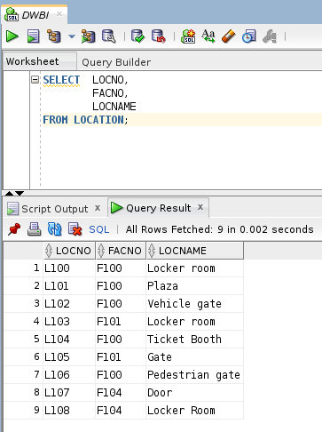

1. **Executing the Update query**

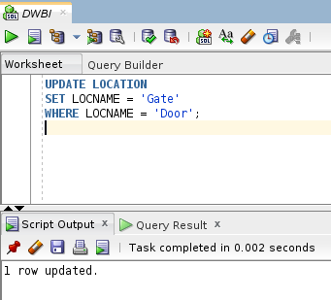

1. **After executing the query**

